INVITATION TO JOIN THE CONSERVATION RUN ORGANIZED BY THE
ZOO KEEPERS ASSOCIATION UGANDA –ZKAU ON 4TH OCTOBER 2026 DURING THE CELEBRATION OF THE INTERNATIONAL ZOO KEEPERS DAY.
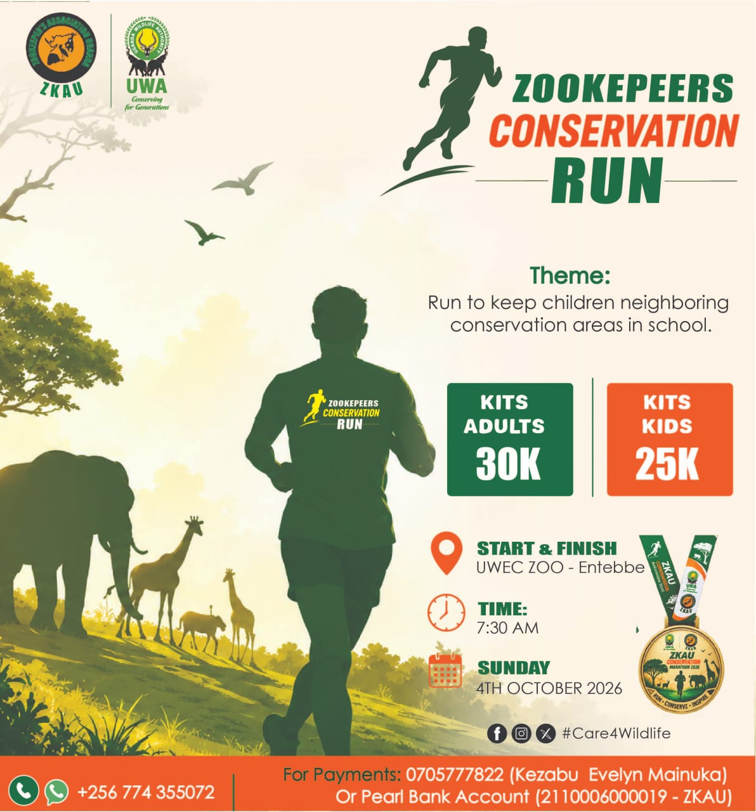
Dear everyone!
The call for your participation is aimed at realising the mission of the run “Keeping Children Near Conservation Areas in School”
We are pleased to have you join us for this cause.

