Zoo Keepers Association Uganda (ZKAU)

Whispers of Zoo Keepers
Article 1: Volume 1 Date: July 25, 2026
Un told experiences of a zoo keeper trainee
"The roar of a lion may be unforgettable, but the quiet dedication of a zoo keeper echoes far beyond the zoo. It echoes in every life protected, every visitor inspired, and every species given another chance to survive."
The public often believes that zoo keepers simply feed animals. This training revealed a much deeper reality. A zoo keeper is a professional responsible for animal behavior observation, animal health observation, animal care, educating the public, nutrition of the animal, animal habitat maintenance, record keeping, and above all, an advocate for wildlife. Every task, whether preparing diets, cleaning enclosures, designing enrichment, and observing behaviors, directly contributes to the physical and psychological well-being of the animals.
Being among the first group of the training program was both an Honor and a challenge. There was no roadmap from previous trainees. Every lesson, every mistake, and every achievement became part of building a foundation for future zoo keepers in Uganda. The most unforgettable moments were those that challenged fear. Hearing a lion's roar at close range shakes more than the ears, it shakes your confidence. Handling reptiles under expert supervision teaches that knowledge is the greatest tool for overcoming fear. It became clear that accidents are prevented not by bravery alone, but by discipline, teamwork, and unwavering adherence to safety protocols.
Knowledge acquired
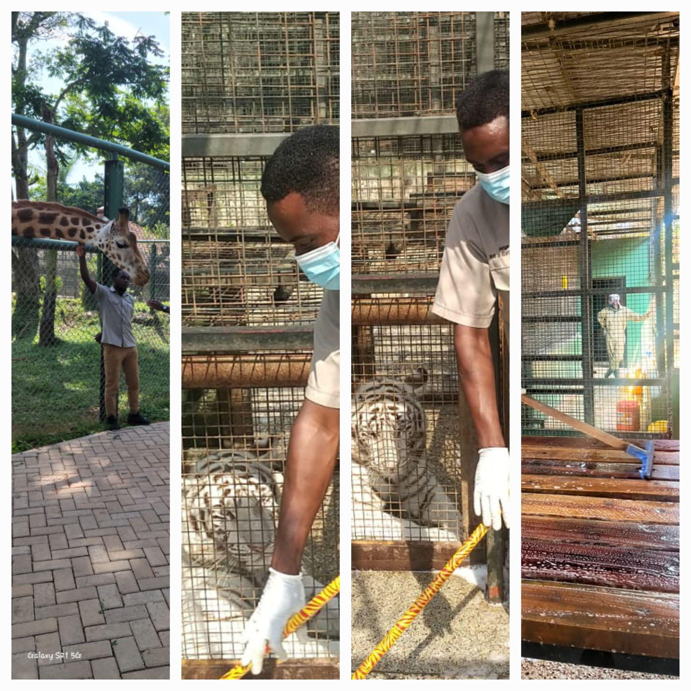
Each day introduced fascinating new knowledge. I learnt about animal welfare and providing opportunities for animals to express their natural behaviors through environmental enrichment. I gained practical skills in enclosure maintenance, safe animal handling, record keeping, waste management, visitor education, and emergency response. One of the most valuable lessons was understanding that every animal is an individual!
The training opened our eyes to the important role of modern zoos. They are no longer merely places for displaying animals. They are centers for conservation, education, scientific research, and breeding programs that help safeguard threatened species for future generations. Every healthy animal in a zoo is an ambassador for the species in the wild and has the potential to inspire thousands of visitors to care about biodiversity and conservation.
Becoming part of the Zoo Keepers Association Uganda (ZKAU) became a remarkable experience. Membership in ZKAU connected me with experienced zoo experts whose mentorship was incredible. Being part of ZKAU gives trainees a sense of belonging to a growing community dedicated to improving animal welfare and strengthening conservation efforts in Uganda.
What a great transformation!
The greatest transformation was personal. The fear that defined the first day slowly became confidence. The uncertainty became competence. Every challenge strengthened resilience, discipline, and humility. True zoo keepers earn the trust of animals through consistency, understanding, and compassionate care. This program has been a life-changing journey. As pioneers of this program, we hope our experiences inspire many younger Ugandans to pursue careers in animal care and wildlife conservation.

Acknowledgements.

I extend my sincere appreciation to the management and staff of the zoo for generously sharing their knowledge. I am also grateful to ZKAU for welcoming us into a professional family. Above all, I thank everyone whose dedication to wildlife reminds us that conservation is not merely about protecting animals. It is about protecting the future of our natural heritage.
By Earnest Duhimbanze
© ZKAU 2026
Entebbe - Uganda

